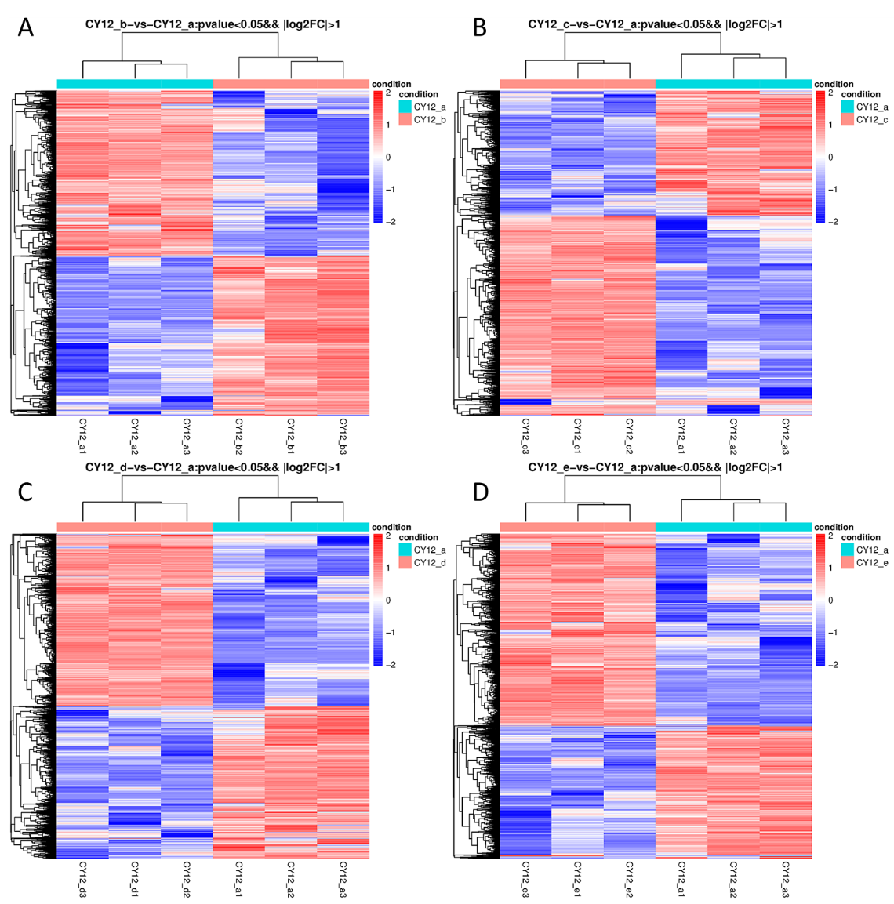
Figure S1 Hierarchical clustering analysis of differentially expressed genes (DEGs) in CY12 at 24h (A), 48h (B), 72h (C) and 7d (D) under Pst-CYR34 infection, respectively. Red color represents upregulated genes, and blue color represents downregulated genes.

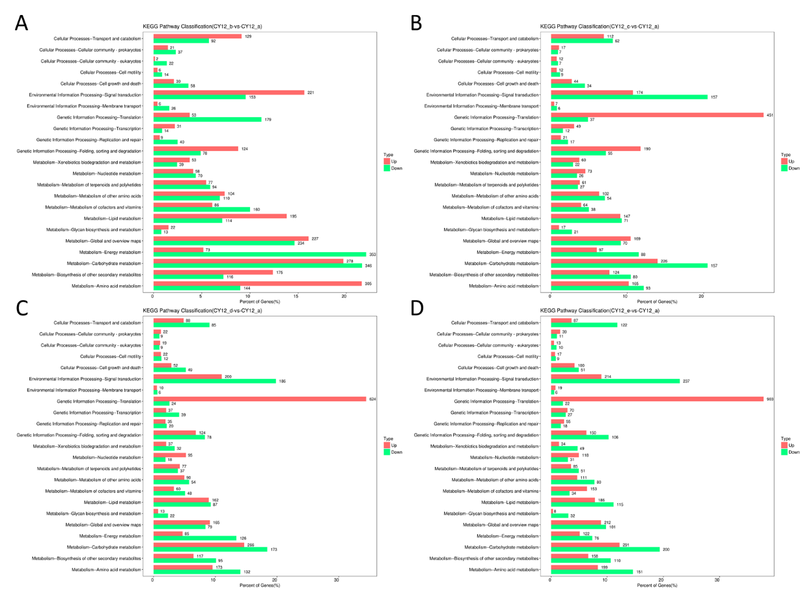
Figure S2 Gene ontology (GO) functional classifications of differentially expressed genes (DEGs) in CY12 at 24hpi (A), 48hpi (B), 72hpi (C) and 7dpi (D).

